Year 1 Autumn Homework – My Place, My Time
22/09/25 – 24/10/25

Some tasks can be completed independently, some will require adult assistance.
If you would prefer to send a photo/video of the homework, please email to sclarke@brockhamptonschool.org

1  English  (Communication, Reading, Writing) | 2  Mathematics and Technology  (DT, Computing, Science) | 3  Creative Arts and Humanities  (Music, Art, Dance, RE, Geography, History)
Reading  Share a favourite book at home and draw your own version of the front cover. Remember to include the title, author and illustrator. | Maths  We have been working on subitising (looking at a set of objects without needing to count them). Play a game with dice or dominoes and try not to count the spots. | Geography  We will be learning about the UK. Find out some facts about the four countries of the UK. Eg. National flower, national food, highest mountain and longest river.
Writing  Practise writing your name using the correct letter formation – starting and ending in the correct place. | Maths  On a laptop, tablet or phone play Hit the Button on  www.topmarks.co.uk/maths-games/hit-the-button  Select; Number bonds, Up to 10, Make 10. | Art  Paint an Autumn picture. Think about the colours we see in Autumn and animals that may be gathering food.
Writing  Write some factual sentences about Autumn. Remember to include capital letters, finger spaces and full stops. Use the sound mat at the front of your homework book to help with spelling. | Design Technology  We will be reading a story called ‘The High Street’. Use a cardboard box to make the shop front of one of the shops/businesses in Bromyard High Street. | PE  Join in with the Autumn yoga session (cosmic Kids) on www.youtube.com  Kids Yoga For Autumn! 🍂 Yoga Club (Week 63) | Cosmic Kids Yoga
Helpful websites | http://www.topmarks.co.uk/ (Maths and English)  https://numbots.com/ (Maths)  http://www.mathplayground.com/ (Maths)  http://www.bbc.co.uk/bitesize (All Subjects)  https://www.phonicsplay.co.uk (Phonics)

Look at the activities above. The activities are divided into three columns. You can choose one activity to complete each week. You could try at least one activity in each column. After that, the choice is yours.
- To help you organise your homework, it is a good idea to do a little every day. You can spend as long as you wish, but around one hour per week should be enough for most activities.
- If you have a brother or sister, you could work on an activity together.
- It is helpful if grown-ups help you, but please do the work yourself.
- The work should be filed/stuck into your homework book.
Remember reading little and often is the best way to develop an understanding of vocabulary, comprehension and fluency. STRIVE FOR FIVE!! Read daily or at least five times a week! Please read for at least 10-15 minutes a day.
Homework Expectations
- Please bring your reading book and reading record into school EVERYDAY.
- Please complete written work in pencil and file/stick into your homework book. Some work may require a photograph.
- Homework is to be handed in whenever it is completed.
- Please work in a way that is clear and easy for people to read.
- Be as creative as you can – use your imagination.
- Feedback from the teacher will be provided in your homework book.

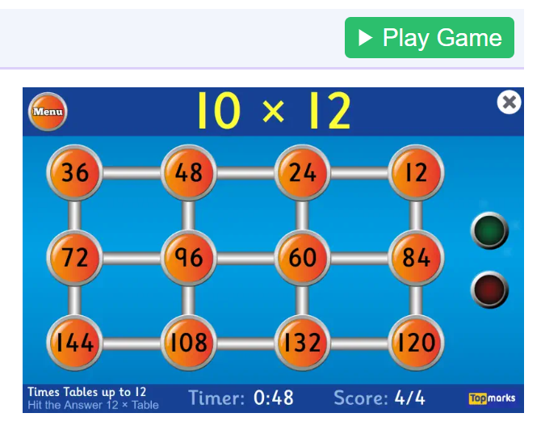
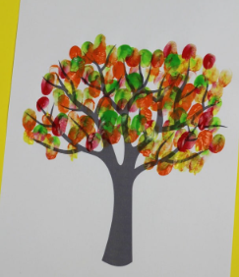

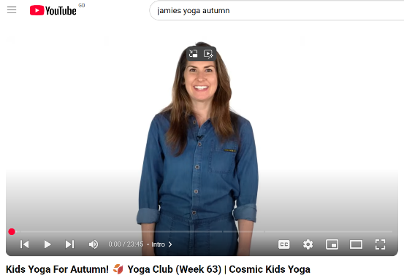

Numbots

Please keep logging into Numbots and working your way through the different levels. The first few levels are easy and very repetitive but it does get harder as you continue. Your child’s login is stuck in the front of the yellow reading record book.
Reading
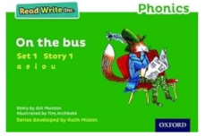
Please try to read with your child at least 5 times a week. The RWI book should be read several times to develop fluency and will be changed every Monday. The other book is chosen by the child and will be changed as soon as they have completed it. We are encouraging the children to choose books which can be easily decoded to make the reading experience more enjoyable for them.
It is important to try to “Fred in your head’ before saying the word aloud.

