Reception Home Learning (Friday 10th March)

Please choose one or more English and Maths activity to complete at home. Record the learning in any way you like. I look forward to seeing you all on Monday.

English
- Our focus book is Handa’s Surprise by Eileen Browne. Click on the following link to hear the story https://www.youtube.com/watch?v=UrANbAjnQgM. Make the main characters from Handa’s Surprise in any way you like (lego, playdoh, toilet rolls, paper puppets) and retell the story. Try and use some words or phrases from the book.
- In Early Bird sessions we are learning to write capital letters. Practise these at home. You could write them on paper, in sand/shaving foam or using paints.
- Write the names of ten different fruits. There is a copy of the sound mat we use in class on the school’s website under: Learn, English, Writing, Sound Mat. Next to the names of the fruits, record the numbers 1-10 to show which fruits are your favourite. 1= favourite, 10= least favourite.

Maths
- Next week, we will be learning about 3D shapes. As a part of this learning, we will be investigating what 2D shapes we can see of the faces of the 3D shapes. Go on a 2D shape hunt around the house. Can you find five objects that are circles, triangles, rectangles and squares? Which is the most common 2D shape you found around the house?
- Cut some 2D shapes into vegetables or sponges (ask an adult to do this for you!) and create a repeating pattern with these shapes. To make it harder use 2 or 3 different colours.

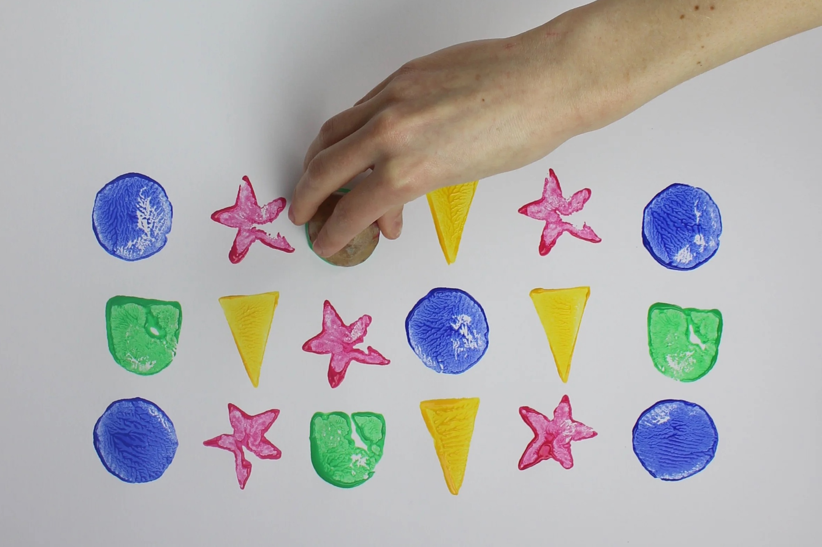
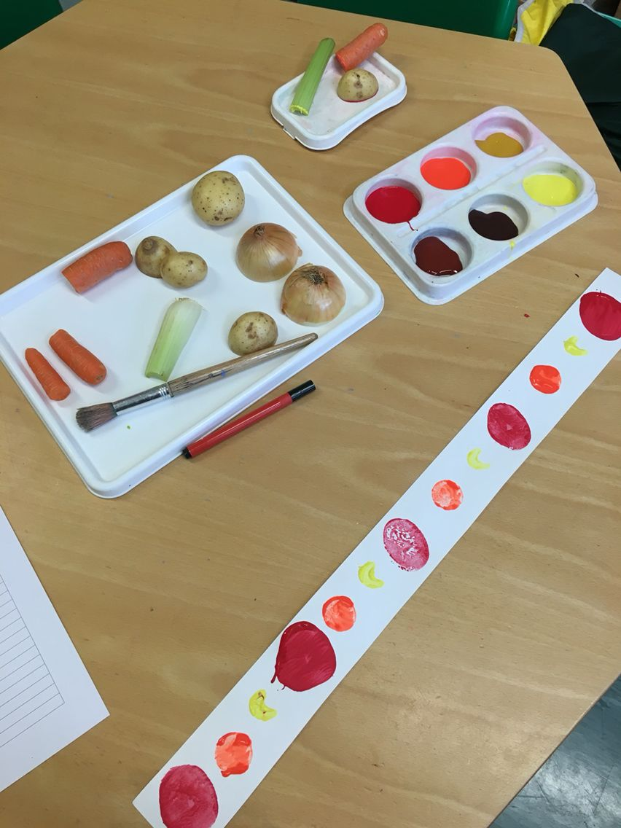
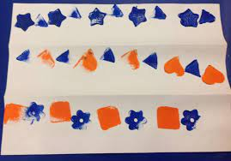

- Play a game of Bottle Bowling. This is a game that can help you find two numbers that total 10. Find 10 bottles/tall objects and arrange them in a pyramid shape. Roll a ball towards the bottles. How many have you knocked down? How many a left standing? Try and record it as a number sentence e.g. 4 + 6 = 10.

